**Nama : Wildan Sania Alfiansyah  
NIM : 18090118  
Kelas : 5C**

1. **Source Code**

Latihan1.php -> application/controllers

Latihan2.php -> application/controllers

view-latihan2.php -> application/views

Model1.php -> application/models

1. **URL**

<http://localhost/pustaka_wildan/index.php/Latihan1>

<http://localhost/pustaka_wildan/index.php/Latihan1/penjumlahan/5/10>

<http://localhost/pustaka_wildan/index.php/Latihan2/penjumlahan/5/10>

1. **Capture Hasil**

**Latihan 1**

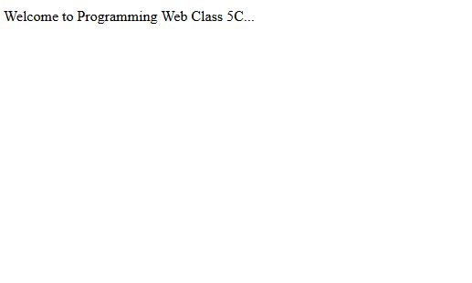



**Latihan 2**

